

**Project Proposal**

**Implementation of Network Topologies using Packet Tracer**

**_____________________**

**304L-Data Communication and Computer Networks Lab**

**Department of Computer System Engineering**

**University of Engineering and Technology Peshawar**

Submitted to: **Dr. Yasir Saleem Afridi**

Submitted by:

**Muhammad Saad 21pwcse1997**

**Muhmmad Umar Jan 21pwcse2000**

**Aiman Maab 21pwcse2076**

Date: **Sun, June 16, 2024**

**Project Proposal: Implementation of Network Topologies using Packet Tracer**

**1. Introduction:** In this project, we aim to create simulations of various network topologies using Cisco Packet Tracer. This will include:

* Star Topology
* Extended Star Topology
* Mesh Topology
* Bus Topology
* Ring Topology
* Hybrid Topology

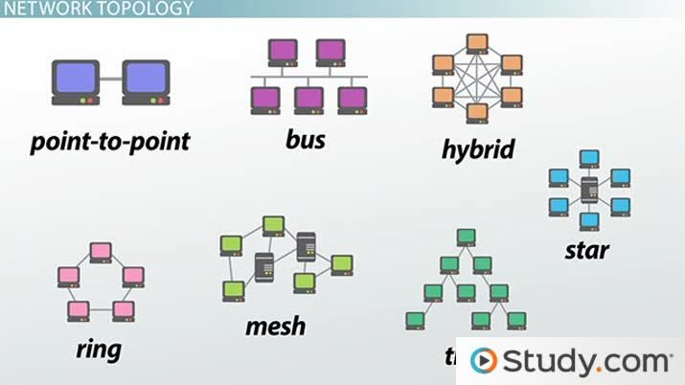

Network Topologies Diagram | Image from www.study.com

**2. Objectives:**

* To design and simulate different network topologies for real-world scenarios.
* To understand and demonstrate the advantages and disadvantages of each topology.
* To simulate network failures and their impact on each topology.

**3. Project Description:**

The project involves using Cisco Packet Tracer to create and test network topologies. We will simulate a company's network, considering its specific needs, to demonstrate how each topology functions in a real-world environment.

**4. Unique Features:**

1. **Real-World Application:** We will implement all the topologies for a company with specific requirements, showcasing how each topology can be tailored to meet these needs.
2. **Simulating Disadvantages:** We will demonstrate the disadvantages of each topology by simulating network failures. For instance, in a Ring Topology, if one part of the ring fails, the entire network goes down. We will show this failure in a separate project file to illustrate the impact.

**5. Methodology:**

* **Design in Packet Tracer:**
  + In this phase we will design our networks by using appropriate devices and then connected them together.
* **Configuring the Devices:**
  + This phase will include configuring the devices like giving IPs to hosts and also configure switches etc.
* **Simulation:**
  + In simulation phase we will try to simulate our network in Packet Tracer.

**6. Expected Outcomes:**

* A clear understanding of how different network topologies operate.
* Insight into the strengths and weaknesses of each topology.
* Practical knowledge of how to design and troubleshoot network topologies using Cisco Packet Tracer.

**7. Conclusion:**

This project covers all kinds of topologies that are used practically in the world nowadays. Here in this project we will try to explain what topology is good what situation and what are the advantages and drawbacks of certain topologies.

______________________________________________________________________________